System Development Life Cycle
The V Model
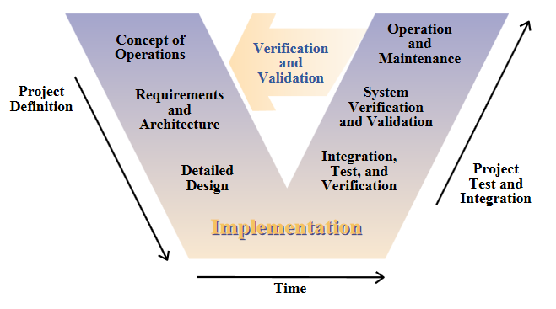
V-Model (or Vee Model)
Though the V-Model can be seen initially as following a traditional waterfall method during the project definition phase with implementation being right at the very bottom of the V, there is an upward waterfall (creating the shape of a V) that allows a level of abstraction to be revisited as improvements are highlighted during the testing and implementation phase. The V model’s main criticisms are that it is perhaps too simple, that its testing regime is very inefficient and it does not respond easily to changes in the overall requirement of the system.

The V-model offers many features, it enables deficiencies to be identified as the project is implemented which is how it is expected many areas for improvement will be discovered in this project, and allows the developer to re-visit down-stream many levels of the project where the deficient might have first occurred. The V-Model then allows the developer to iteratively re-develop that part of the project and then continue to move down the waterfall integrating the changes as the project moves along; with the cycle repeated as new deficiencies are discovered.

Dual Vee Model

The Dual Vee Model is a development of the V-Model whereby multiple concurrent V-Model projects are managed and developed simultaneously as parts of a much larger project; which is developed as a V-Model itself. In the Dual Vee method a ‘master’ V model known as the Architecture Vee manages smaller sub-developments known as Entity Vee models which are individual projects and which follow their own individual V-Model. This methodology is especially suited to large scale multi-project projects that because of their complexity must be separated into smaller individual projects that are then developed in their own right but which then form an element of the overall project. As with the V-Model individual entities can be developed iteratively based on their own deficiencies or as a result of the impact felt of iterations in other entities to which it or the Architecture Vee has a dependent relationship.
 | Advantages | Disadvantages
The V Model | - The users of the V-Model participate in the development and maintenance of The V-Model. A change control board publicly maintains the V-Model. The change control board meets anywhere from every day to weekly and processes all change requests received during system development and test.  - The V-Model provides concrete assistance on how to implement an activity and its work steps, defining explicitly the events needed to complete a work step: each activity schema contains instructions, recommendations and detailed explanations of the activity. | - Takes longer as customers are able to go back to previous steps to change things. Due to this some projects are known not to ever finish.

